Good morning everyone,
I hope you all had a nice weekend. This week, Ms Sorensen and I have included some fun activities as well as a little bit of English and Maths work. I hope you enjoy some of the ideas posted below. Have a great week.
Ms Byrne

Suggested Work for Monday 8th-Friday 12th June
This week I would like you to send me photos of your minibeast scavenger hunt or any photos of the active work included in this week’s homework list. Another piece of work you could send me is your gratitude list, your decorated stones/shells or your Friday Spelling Test. My email address is msb1@realtnamaradonacarney.ie which parents can also use for any queries they may have about their child’s school work.
Please remember that the lists of weekly work posted here are just suggestions of the schoolwork that the girls could being doing at home. It is not expected that every child will be able to complete all of the work listed below.
Monday 8th June
English: Spellings- ‘ur’ sound. Your daughter does not have the spelling list for this week in her spelling notebook, so please have her copy the list below into this notebook. Can you write a list of some other words with this sound? Learn spellings 1-3 from the list today.
‘ur’
not
sum
next
turn
nurse
turkey
purple
love
cover
hamburger
​Geraldine the Giraffe learns the ‘ur’ sound too!
https://www.youtube.com/watch?v=Q49YSWKPyVo&t=8s
Play some games on the ‘Phonicsplay’ website to practise the ‘ur’ sound and other digraphs.
https://new.phonicsplay.co.uk/
You can also play this ‘ur’ Roll & Read game.
https://www.twinkl.ie/resource/t-l-4046-phase-3-ur-phoneme-roll-and-read-mat
Handwriting- 'Go with the Flow' page 60. Learn to join ‘ff’ and ‘rr’.
You can watch ‘Flowie’ the dog showing you how to do all the letter joins here. http://data.cjfallon.ie/resources/gwtf-handwriting/index.html#!/book-sections/2/section-activities/1
Maths: Master Your Maths pg 62 Monday section. Please write number sentences (sums) for word problems 11&12.
Tables: Today you are going to revise the 10+ tables. Please revise the first 7 number facts today.
10+ 0 = 10
10+ 1 = 11
10 + 2 = 12
10 + 3 = 13
10 + 4 = 14
10 + 5 = 15
10 + 6 = 16
10 + 7 = 17
10+ 8 = 18
10 + 9 = 19
10 + 10 = 20
10 + 11 = 21
10 + 12 = 22
S.E.S.E Minibeasts
Today we are going to learn about minibeasts! Can you tell your parents or siblings what you already know about minibeasts? Minibeasts are small animals. All minibeasts have one thing in common: they do not have a backbone. Minibeasts are all around us, they are the largest group of animals on earth. Go to pg 22 of your Starlight book to read some more interesting facts about minibeasts!

Take a look at these minibeasts. Do you recognise most of them?
https://www.twinkl.ie/resource/t2-s-1165-insects-photo-powerpoint
Read these cards to find out more information about different minibeasts.
https://content.twinkl.co.uk/resource/dc/89/t2-s-1169-insect-information-cards-.pdf?__token__=exp=1591371072~acl=%2Fresource%2Fdc%2F89%2Ft2-s-1169-insect-information-cards-.pdf%2A~hmac=b77670412115bf663580a1b601e18c38ec0939a7009a38c552bf0f46483022d3
Watch this video to find out more about minibeasts!
https://www.youtube.com/watch?v=rKQfJFAHW8Q
Use the clues to guess what the minibeast is!
https://www.twinkl.ie/resource/t-t-5145-minibeasts-what-am-i-interactive-powerpoint-game
Activity:
Go on a minibeast scavenger hunt in your garden, local park or any green area that you have access to! See how many different types of minibeasts you can find and tick them off on your list! Have fun
https://content.twinkl.co.uk/resource/0f/ff/t-t-019-eyfs-minibeast-hunt-checklist-_ver_2.pdf?__token__=exp=1591370654~acl=%2Fresource%2F0f%2Fff%2Ft-t-019-eyfs-minibeast-hunt-checklist-_ver_2.pdf%2A~hmac=af42ae6053396b44fa9f833f308f9b64342f7b8d468a0c97d3756c26f2e6581e
***There are lots more ‘minibeast’ activities and resources available on twinkl.

Tuesday 9th June
English: Spellings- ‘ur’ Learn spellings 4-6 from list.
Story: Mad About Minibeasts https://youtu.be/3rDQN8I7RkY
Use your imagination and see if you can make up a different ending to the story.
Maths: Master your Maths page 62, Tuesday section. Please write number sentences (sums) for word problems 11&12.
Tables: Please revise the last 6 number facts from the 10+ tables today.
10+ 0 = 10
10+ 1 = 11
10 + 2 = 12
10 + 3 = 13
10 + 4 = 14
10 + 5 = 15
10 + 6 = 16
10 + 7 = 17
10+ 8 = 18
10 + 9 = 19
10 + 10 = 20
10 + 11 = 21
10 + 12 = 22
P.E Download this link and follow the ‘What’s Your Name’ workout.
file:///C:/Users/Teacher/Desktop/Covid%2019%20Photo%20album/WHATS%20YOUR%20NAME%20WORKOUT.webp

Wednesday 10th June
English: Spellings- ‘ur’ Learn spellings 7-9 from list.
Handwriting- 'Go with the Flow' page 61. Learn to join ‘qu’ and ‘bb’
Maths: Master your Maths page 63, Wednesday section. Please write number sentences (sums) for word problems 11&12.
Tables: Today you are going to revise the 11+ tables. Please revise the first 7 number facts today.
11+ 0 = 11
11+ 1 = 12
11+ 2 = 13
11+ 3 = 14
11+ 4 = 15
11+ 5 = 16
11+ 6 = 17
11+ 7 = 18
11 + 8 = 19
11 + 9 = 20
11 + 10 = 21
11 + 11 = 22
11 + 12 = 23
P.E. & Music Get moving with some of these fun action songs from ‘The Learning Station’. https://www.youtube.com/playlist?list=PL17F1F193E453DB97

S.P.H.E There are many things in our lives that we should be grateful for; our family and friends, our cosy homes, our school, sunny days, nature etc. Sometimes thinking about these things or even writing them down makes us appreciate them a little more every day. Follow the list below and go on a ‘Gratitude Scavenger Hunt’. You could also write a list of all of the things that you are grateful for today and decorate it nicely!
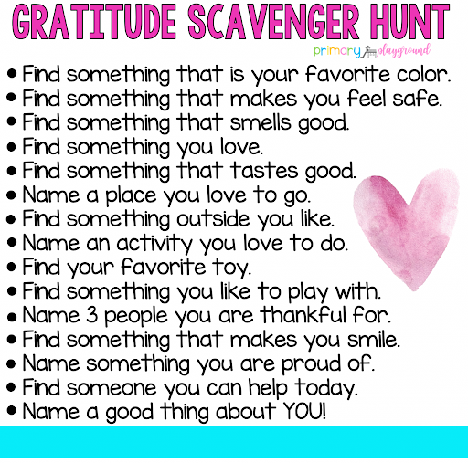

Thursday 11th June
English: Story ‘The Cautious Caterpillar’ https://www.twinkl.ie/resources/ks1-twinkl-originals-key-stage-1/twinkl-educational-publishing-fiction-story-books-story-primary-resources-english-key-stage-1/the-cautious-caterpillar-fiction-ks1-twinkl-originals
Spellings- ‘ur’ learn and revise
Maths: Master your Maths page 63, Thursday section. Please write number sentences (sums) for the word problems 11&12.
Tables: Please revise the last 6 number facts from the 11+ tables today.
11+ 0 = 11
11+ 1 = 12
11+ 2 = 13
11+ 3 = 14
11+ 4 = 15
11+ 5 = 16
11+ 6 = 17
11+ 7 = 18
11 + 8 = 19
11 + 9 = 20
11 + 10 = 21
11 + 11 = 22
11 + 12 = 23
Art /SPHE: Stay connected: Why not brighten up someone’s day this week; decorate stones or shells (like the samples below) and drop them in different places on your next walk for others to see!

Friday 12th June
English: Spellings- Ask a parent to test you on the ‘ur’ spelling list by calling out these sentences for you to write down. The 10 words from the list are underlined.
1. The nurse has a purple watch.
2. Did you do the next sum?
3. Do not turn over the cover of the book.
4. I love to eat hamburgers.
5. Did you see the turkey on the farm?
Handwriting- 'Go with the Flow' page 62. Learn to join ‘mm’ and ‘dd’.
Read this poem aloud and add your own actions
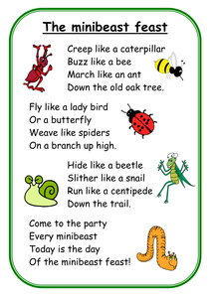
Maths: Speed test on +10 and +11 tables. (90 seconds)

S.P.H.E: Go on a colour walk/cycle It is important to stay active for our bodies and minds. Get outdoors, take in some fresh air and appreciate the beauty of nature all around you!
https://drive.google.com/file/d/0B-cVjZBMBNNXTDVVbUNtLWV4UGc/view

RTE Home School Hub-This programme is aimed at children from 1st to 6th class and is currently on every weekday from 11am to 12pm on RTE2. It is presented by three primary school teachers and covers a wide range of subjects across the curriculum. (This programme is also available to stream on RTE player). Children can also access lots of engaging, educational content online, which is available on www.rte.ie/learn​
This week’s ‘School Hub’ timetable for 1st/2nd class this week is as follows:
Monday- English: Writing Skills
Tuesday- Drama: Body, Eyes and Props
Wednesday- Science: Parachutes
Thursday- Gaeilge: Cluichí sa Bhaile
Friday- Geography: The Moon

